**Ideation Phase**

**Define the Problem Statements**

|  |  |
| --- | --- |
| Date | 23 May 2023 |
| Team ID | NM2023TMID11307 |
| Project Name | Estimation and Prediction of Hospitalization and Medical Care Costs |
| Maximum Marks | 2 Marks |

**Customer Problem Statement Template:**

The customer, a healthcare organization or government agency, is seeking an estimation of healthcare expenditures related to obesity in order to develop cost-effective prevention strategies**.**

Obesity is a significant public health concern worldwide, associated with numerous health risks and substantial healthcare costs. The customer recognizes the need to address obesity through effective prevention strategies to reduce the burden on the healthcare system and improve overall population health. However, limited resources require a cost-effective approach, necessitating an estimation of healthcare expenditures associated with obesity to guide the development and implementation of prevention programs.

**Example:**

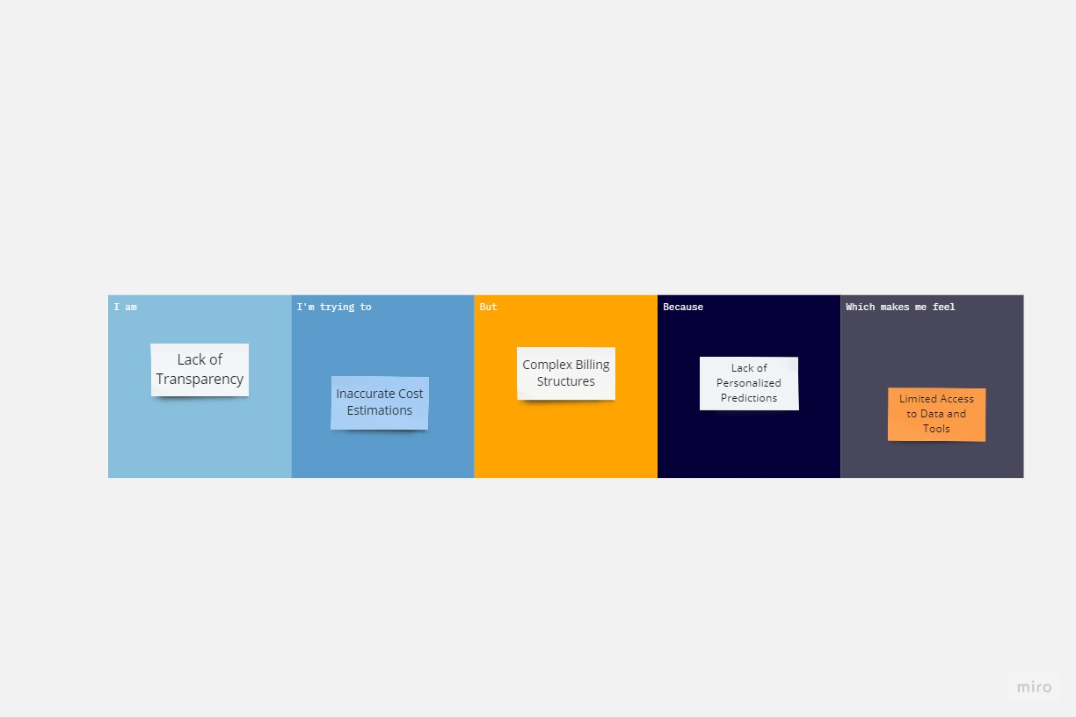

|  |  |  |  |  |  |
| --- | --- | --- | --- | --- | --- |
| **Problem Statement (PS)** | **I am (Customer)** | **I’m trying to** | **But** | **Because** | **Which makes me feel** |
| PS-1 | Lack of Transparency | Inaccurate CostEstimations | Complex Billing Structures | Lack of Personalized Predictions | Limited Access to Data and Tools |